**UI for Hostel Management System**

*Source Code -*

<!DOCTYPE html>

<html lang="en">

<head>

<meta charset="UTF-8">

<meta name="viewport" content="width=device-width, initial-scale=1.0">

<title>Student Accommodation</title>

<link rel="stylesheet" href="styles.css">

</head>

<body>

<div class="login-container">

<h2>Login</h2>

<input type="text" id="username" placeholder="Enter Username">

<input type="password" id="password" placeholder="Enter Password">

<button onclick="login()">Login</button>

<p id="error-message" class="error"></p>

</div>

<script src="script.js"></script>

</body>

</html>

<!DOCTYPE html>

<html lang="en">

<head>

<meta charset="UTF-8">

<meta name="viewport" content="width=device-width, initial-scale=1.0">

<title>hostellia - Book</title>

<link rel="stylesheet" href="styles.css">

<script defer src="https://cdnjs.cloudflare.com/ajax/libs/three.js/r128/three.min.js"></script>

<script defer src="script.js"></script>

<script type="module" src="https://unpkg.com/@google/model-viewer/dist/model-viewer.min.js"></script>

<style>

body {

font-family: Arial, sans-serif;

background: linear-gradient(to right, white,yellow);

color: #000;

text-align: center;

margin: 0;

padding: 0;

}

header {

display: flex;

justify-content: space-between;

align-items: center;

padding: 15px 30px;

background: #000;

color: #fff;

}

.logo-container img {

height: 90px;

margin-center: 70px;

}

.nav-links {

display: flex;

gap: 50px;

}

.nav-links a {

color: #fff;

text-decoration: none;

font-weight: bold;

}

.model-container {

display: flex;

justify-content: center;

align-items: center;

margin-top: 20px;

}

model-viewer {

width: 200px;

height: 200px;

}

.search-container {

margin-top: 20px;

}

.search-container input {

padding: 10px;

width: 300px;

font-size: 16px;

}

.search-container button {

padding: 10px 15px;

font-size: 16px;

background: black;

color: white;

border: none;

cursor: pointer;

}

.image-container {

display: flex;

justify-content: center; /* Centers images horizontally */

align-items: center;

flex-wrap: wrap; /* Ensures responsiveness */

margin-top: 20px; /* Adds space below the search bar */

gap: 20px;

}

.static-images {

align-items: center;

display: flex;

justify-content: center;

gap: 30px;

margin-top: 50px;

}

.static-images img {

width: 260px;

height: 160px;

object-fit: cover;

border-radius: 10px;

box-shadow: 2px 2px 10px rgba(0, 0, 0, 0.1);

}

</style>

</head>

<body>

<header>

<div class="logo-container">

<img src="https://th.bing.com/th/id/OIP.RvhRp6Dxd4SrCJzmROIQwgHaGc?rs=1&pid=ImgDetMain" alt="vShopping Logo">

<h1>Hostellia</h1>

</div>

<nav class="nav-links">

<a href="#">Hostels</a>

<a href="#">PG</a>

<a href="#">Mess</a>

<a href="#">Contact</a>

</nav>

</header>

<div class="search-container">

<input type="text" id="productSearch" placeholder="Search for Hostel/PG/Mess...">

<button onclick="searchProduct()">Book</button>

</div>

<!-- Static Images Section -->

<div class="static-images">

<div>

<img src="https://th.bing.com/th/id/OIP.vSJhciHZ8DP8YGiTQdYepwHaFj?w=278&h=209&c=7&r=0&o=5&dpr=1.3&pid=1.7" alt="Hostel">

<p>Comfortable & affordable hostels</p>

</div>

<div>

<img src="https://cozydorms.com/blog/wp-content/uploads/2021/02/newblog.png" alt="PG">

<p>Fully furnished PGs</p>

</div>

<div>

<img src="https://th.bing.com/th/id/OIP.iKK6tlz3JChgrJp9udIfdAHaER?rs=1&pid=ImgDetMain" alt="Mess">

<p> Hygenic & delicious Food</p>

</div>

<div>

<img src="https://th.bing.com/th/id/OIP.YMJoSZSR_UOxgUIaAZIbiQHaE7?rs=1&pid=ImgDetMain">

<p>Sport Activities</p>

</div>

<div class="model-container">

<model-viewer src="samsung_s25.glb" alt="Samsung S25" auto-rotate camera-controls></model-viewer>

</div>

<div class="results" id="results"></div>

<script>

async function searchProduct() {

const product = document.getElementById("productSearch").value;

if (!product) {

alert("Please enter a product name.");

return;

}

document.getElementById("results").innerHTML = `<p>Fetching prices for "${product}"...</p>`;

try {

const response = await fetch(`https://api.example.com/search?query=${product}`);

const data = await response.json();

let priceList = `<h3>Price Comparison for "${product}"</h3><ul>`;

data.forEach(item => {

priceList += `<li>${item.store}: ₹${item.price}</li>`;

});

priceList += "</ul>";

document.getElementById("results").innerHTML = priceList;

} catch (error) {

document.getElementById("results").innerHTML = `<p>Error fetching product prices. Please try again.</p>`;

}

}

</script>

</body>

</html>

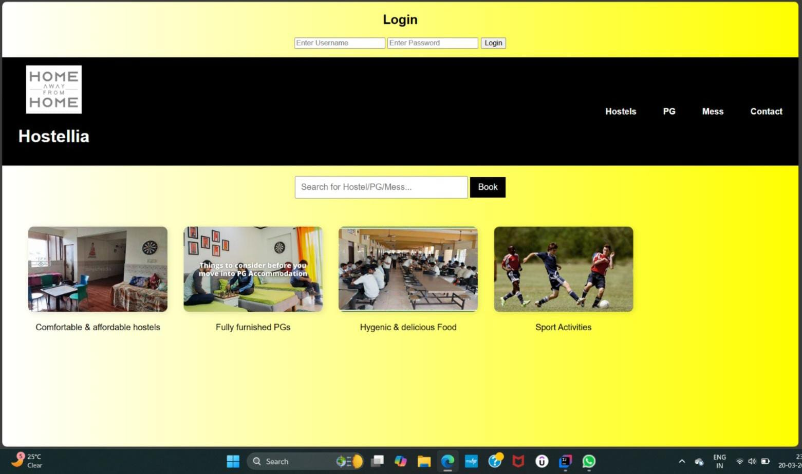*Output-*